Task 1

User Profiles, Stories and Journeys

**Name:**  Daniel

**Age:**  27

**Employment:**  Regular User

**Characteristics:**  Visually impaired  
 Prefers contrasting colours

**Goals:**  Learn what makes a well-designed webpage.  
 Learn how to guide user focus when designing webpages.

**Priorities:**  A website that provides clear distinction between its different sections to allow him to easily navigate it.

**Dislikes:** A website that is difficult to use with his impairment.

**Favoured System:** Desktop

**User Story:** As a someone who is visually impaired, I would like a website that is easily visible regardless of my impaired vision.

**User Journey:** User opens website.  
User sees that the website is clear to them.  
User continues navigating the webpage.  
  
User opens website.  
User cannot understand the website.  
User clicks off the website.

**Name:**  Meriol

**Age:**  19

**Employment:**  Student

**Characteristics:**  Mobile User

**Goals:** Wants a website that adapts well to mobile use.

**Priorities:** A mobile-friendly website.

**Dislikes:** A website that breaks if used on mobile.

**Favoured System:** Mobile

**User Story:** As a mobile user, I want a website I’ll be able to easily access and navigate on mobile devices.

**User Journey:** User opens the website homepage vertically on a mobile device.  
User sees that the page fits with both horizontal and vertical positioning of the screen.  
User navigates to various other sections of the webpage as they read through the site.  
User sees the site as a whole is mobile friendly.

**Name:**  Warren

**Age:**  30

**Employment:**  Student

**Characteristics:**  UX Enthusiast

**Goals:** Wants to learn more about UX design.

Wants to be able to contact Irene with any questions regarding how she designs her websites.

**Priorities:** An informative, accurate website.An easily usable comments section.

**Dislikes:** A clunky, unappealing website filled with placeholder or useless text.

**Favoured System:** Mobile

**User Story:** As a UX enthusiast, I want to have a website that is functional, informative and visually appealing, so that I can learn her techniques for my own improvement.

**User Journey:** User opens the webpage.  
User clicks on the navigation button ‘Contact’.  
User scrolls down to look at the comments.  
User taps on the comment form at the bottom of the screen.  
User types in their name and what they want to say.  
User taps the ‘Post Comment’ button.  
The page scrolls down to their new comment.  
  
User opens the webpage.  
User clicks on the navigation button ‘Contact’.  
User scrolls down to look at the comments.  
User taps reply to a comment they wish to post a response to.  
‘@CommentUser#ID’ is added to the start of the description in the comment form, and a keyboard is opened up.  
User types their name and reply to the comment.  
User taps the ‘Post Comment’ button.  
The page scrolls down to their new comment.

**Name:**  Indred

**Age:**  38

**Employment:**  Programmer and Database Consultant

**Characteristics:**  Prefers an interactive site.  
 Would like a site that is managed using SQL, or another DBMS.

**Goals:** –

**Priorities:** The website should be interactive and easily updatable using SQL.

**Dislikes:** Badly formatted website with sloppy code.

**Favoured System:** Desktop

**User Story:** As a programmer and a database expert, I want to see use of a database manager to store calendar events and comments, so they can be easily updated from the front and back-ends, where appropriate.

**User Journey:** User enters the site.  
User looks at the navigation menu in the home section and sees that there are calendars and a comment section.  
User navigates to the comments section to query about how it handles event dates and comment requests, and how they are stored and displayed.

Site Map

As a tree map

**Calendars**

**CommentSection**

**About Irene(Homepage)**

**Yoga Classes**

**Conferences**

**Jump toParent Comment**

**Reply to Comment**

**Three External Links**

Task 2

Description of Each Page

**About Irene**

* The home page will have the most text, as shown below:

“Most designers naturally want to join a company where the design of the product is already strong, believing it reflects the value the company places on design and how well designers are set up to succeed. I am an Operating Partner at Khosla Ventures, where I work with portfolio companies to make their design great. My dedication is to raising the strategic value of design and user research through better methods, practices, processes, leadership and quality.

I am international, travelling around the world to speak at conferences many times a month. I talk on UX design, integration between technology and design, and many other aspects of interface design.  
 I am also a yoga instructor. I hold classes every Tuesday, emphasising physical fitness and health to allow my students to learn to grow and succeed not only in their careers, but also in life as well.  
 You can see when my functions and classes run on the ‘Calendars’ tab, or if you’re on mobile, you can click on the ‘Events’ tab. To contact me using my social media or the site’s in-built forum, you can access the ‘Contact’ tab.”

* I will have three external links in this section.
  + <https://twitter.com/ireneau>
  + <https://www.linkedin.com/in/ireneau>
  + <https://www.khoslaventures.com/team/irene-au>
* I will use four images in the home page:



<https://www.mindtheproduct.com/2014/10/irene-au-design-is-as-important-as-technology/>



<http://zurb.com/article/525/podcast-of-irene-au-s-talk-on-how-google->

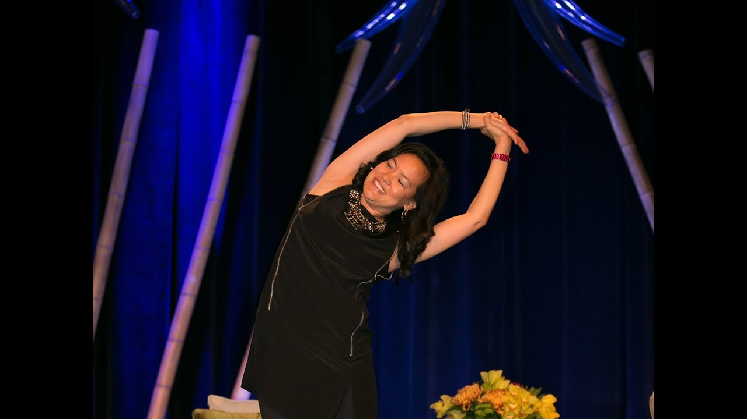

The thumbnail from <https://www.youtube.com/watch?v=3DkaMlg7OCo>

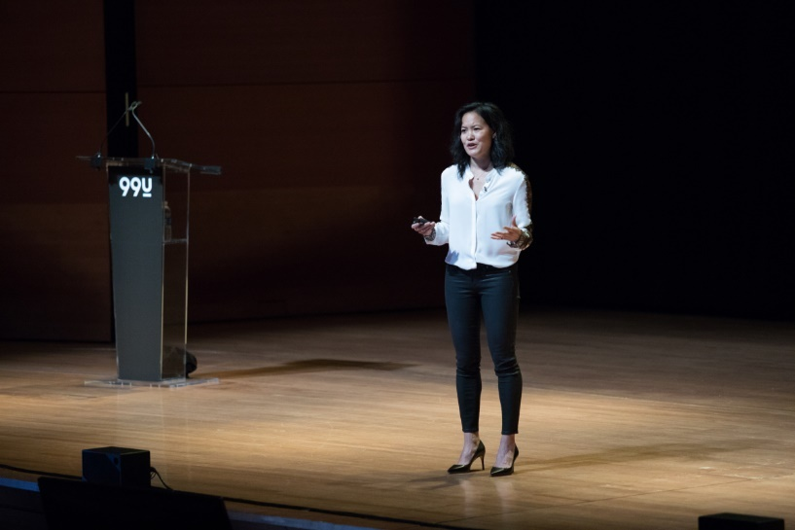

<http://99u.com/videos/55969/irene-au-the-architecture-of-creative-collaboration>

**Irene’s Events**

* This section will have two segments, one for yoga classes and one for conference events. For each section, there will be a calendar with names and dates displayed.
* In desktop, the events will be displayed as rows of seven boxes up until the end of the month, with each box containing day of the month (numerical), and if an event is happening on that date a name will be displayed. If the user hovers over the event, they will see a description of the event. The tooltips for these events will not behave entirely like normal dividers. They will be rounded instead of sharp, and will fade in rather than simply appearing. This more gentle feel will likely alert the user that this element is not a regular element, and will make it stand out more.
* In mobile, the events will be displayed as a list of containers with the name, date and description displayed inside. The date would be represented as ‘<Day> <Number (Ordinal)>’.
* I will have events already contained within each calendar, to show the functioning and formatting of comments.
  + **Yoga classes**
    - 2019-12-10 (18:00-19:00) – Pilates Class: This is a regular pilates class. Stretching will continue for ten minutes, and we will be focusing the rest of the class on core strength and breathing.
    - 2019-12-17 (18:00-19:00) – Fitness: We will be focusing on physical stamina in this class. Stretches will continue for fifteen minutes, and after this, we will be attempting a series of bleep tests.
    - 2019-12-24 – No Class Today: As I need to travel to Tokyo for a design conference today, there shall be no regularly scheduled class today. Best wishes, and enjoy the new year.
    - 2019-12-31 – New Year’s Eve: As it is the end of the year, there shall be no regularly scheduled class today. Best wishes, and enjoy the new year.
  + **Conferences**
    - 2019-12-05 (09:00-11:00) – UX design in extreme environments: Held in the CCT conference centre at Canary Wharf, I will be talking about how we can best incorporate UX design into extreme conditions, such as in engineering in space, and in the deep oceans.
    - 2019-12-12 (13:00-15:00) – HCI for the elderly: Held in the Cavendish conference centre in London, the main focus of this conference is how designing for the elderly and the physically impaired can present challenges that must be understood if we wish to cater to the needs of all people in our communities.
    - 2019-12-26 (17:00-19:00) – Incorporating procedural scripting into HCI: Held in the Tokyo Shinagawa conference centre, this conference will detail how procedural scripting, both client-side and server-side, can be used to improve dynamic HCI.

**Comment Section**

* The comment’s section will be contained in a Reddit-like parent-child format, where all comments will be visible on the page and will require scrolling.
* The link to jump to a comment is ‘@<CommentPoster>#<CommentID>’.
* I will have three comments already contained within the comment’s section, to show the functioning and formatting of comments. Indented in reply format, these will be:
  + **Daniel:** “Hello Irene.  
    I was curious about the design of this website. It is very stark and blocky, with no colour and a lacking amount of contrast. I was wondering if it could be changed, as it may be difficult to understand for someone with visual impairments like me.”
    - **Charles Knight:** “That does appear to be an issue. Perhaps the link navigation buttons could be improved with colour. Currently, the buttons darken when clicked, which could make them difficult to see with a dark background. Maybe instead, we could incorporate buttons that change colour and brighten when hovered over and clicked.”
      * **Daniel:** “I feel that would be a good change. Thank you.”

Site Look and Feel

Background

I want the site to have a blocky, but professional feel, and as such, found two potential backgrounds I wanted to use:



The first design. This one will not be used.  
Image Source: <http://1024x.net/65/-/Play_Cube_Seamless_Pattern/>

The second design. This is the one I will be using.   
Image Source: <https://designbundles.net/davidzydd/336059-24-seamless-grey-square-patterns>

I had trouble deciding between the two, however I preferred both the flat shade of the second one, as well as its regularity and diagonal contrast between the horizontal structure of the foreground. I found that the gradient shading of the first image made it much more difficult to distinguish dividers, whereas the final background design was simpler and more understandable.

Colour Choice

This site will likely place very little emphasis on colour, focusing much more on contrast. This allows me to bypass the problem of colour-blindness in some visitors, and allows me to focus on making the text easily readable. As such, outside of photos and other images there will be no colour except black, white and varying shades of grey.

The site will use greyscale to draw the user’s attention to where there is light, and where there is darkness. This will allow me to hold important aspects of the page in very contrasting areas, such as making black dividers against the grey background that in themselves hold white text for the title, or the other way round for white dividers with black text.

Font Choice

For the titles, I wanted to go for something relatively clean, but also one that whilst being clear and readable, also held a bit of style to it as well to allow some flair to shine through as well. As such, I chose the Colder Weather font from Dafont.com. The text ornaments also swayed my decision as well. They will be incorporated as hangers for the titles.



◄ An example of Colder Weather in use.

Photo taken by @wiradyatmika

Font source: <https://www.dafont.com/colder-weather.font>

I thought the font was appropriately striking, but not too overpowering or flowery, which I believe fit the theme I was trying to convey.

Site Mockups

Desktop

**Homepage:**

Link

Irene Au

Who am I?

Most designers naturally want to join a company where the design of the product is already strong, believing it reflects the value the company places on design and how well designers are set up to succeed. I am an Operating Partner at Khosla Ventures, where I work with portfolio companies to make their design great. My dedication is to raising the strategic value of design and user research through better methods, practices, processes, leadership and quality.

I am international, travelling around the world to speak at conferences many times a month. I talk on UX design, integration between technology and design, and many other aspects of interface design.

Image

Link

Link

Link

Image

Image

External Link

External Link

External Link

**Irene’s Events:**

Link

Irene Au

When am I On?

Yoga Classes for <Month> <Year>

Design Conferences for <Month> <Year>

Link

Link

Link

**Contact Irene:**

Link

Irene Au

Write your Comment

Link

Link

Link

Post Comment

User1 YYYY-MM-DD hh:mm:ss No. 1Reply

Comment Content

User2 YYYY-MM-DD hh:mm:ss No. 2Reply

@User1#1 Comment Content

User1 YYYY-MM-DD hh:mm:ss No. 3Reply

@User2#2 Comment Content

User4 YYYY-MM-DD hh:mm:ss No. 4Reply

Comment Content

Mobile

**Homepage:**

Link

Irene Au

Who am I?

Most designers naturally want to join a company where the design of the product is already strong, believing it reflects the value the company places on design and how well designers are set up to succeed. I am an Operating Partner at Khosla Ventures, where I work with portfolio companies to make their design great. My dedication is to raising the strategic value of design and user research through better methods, practices, processes, leadership and quality.

As can be seen here, this is the general retention rate of a site without good HCI. This is improved by a variety of factors that contribute to good HCI, such as word styling, colour palette and divider placement.

Graph

Link

Link

Link

**Irene’s Events:**

Link

Irene Au

When am I On?

Yoga Classes for <Month> <Year>

Design Conferences for <Month> <Year>

Link

Link

Link

**Contact Irene:**

Link

Irene Au

Link

Link

Link

User1 No. 1Reply

Comment Content

User2 No. 2Reply

@User1#1 Comment Content

User1 No. 3Reply

@User2#2 Comment Content

User4 No. 4Reply

Comment Content

User4 No. 5Reply

Comment Content

Post Comment

Fixed to the bottom of the screen.

Task 4

Contrast

One of the metrics I tested against was contrast. For this, I utilised Mozilla Firefox’s built-in accessibility tools to assess contrast easily directly from the webpage, however for cases where that was not possible, I used <https://contrastchecker.com/> to test the rest.

|  |  |  |
| --- | --- | --- |
| Section | Contrast | Pass/Fail |
| Title |  | Pass |
| Passive Navigation Link |  | Pass |
| Active Navigation Link or other Active Divider | <https://contrastchecker.com/?c=FFFFe7&b=3f3f0c> | Pass |
| Home-page Paragraph Text |  | Pass |
| Text on a White Comment |  | Pass |
| Reply Link on a White Comment |  | Pass |
| Parent Link on a White Comment |  | Pass |
| Text on a Black Comment |  | Pass |
| Reply Link on a Black Comment |  | Pass |
| Parent Link on a Black Comment |  | Pass |
| Divider subsection against main divider | <https://contrastchecker.com/?c=030303&b=0f0f0f> | Fail |
| I remedied the single failure by decreasing the opacity of the main dividers slightly to 0.6, whilst adding a small piece of code to keep the subsections at 0.8 opacity. It increased the score a small amount by 0.19, however since this contrast isn’t too important thanks to the hover and active highlighting, this increase is reasonable enough.  → | | |

Code Validation

**Note:** Since I make heavy use of require and include functions in my code, the validator does not pick up on these external links, and will often declare things as missing when they are actually contained within an external file, as such:

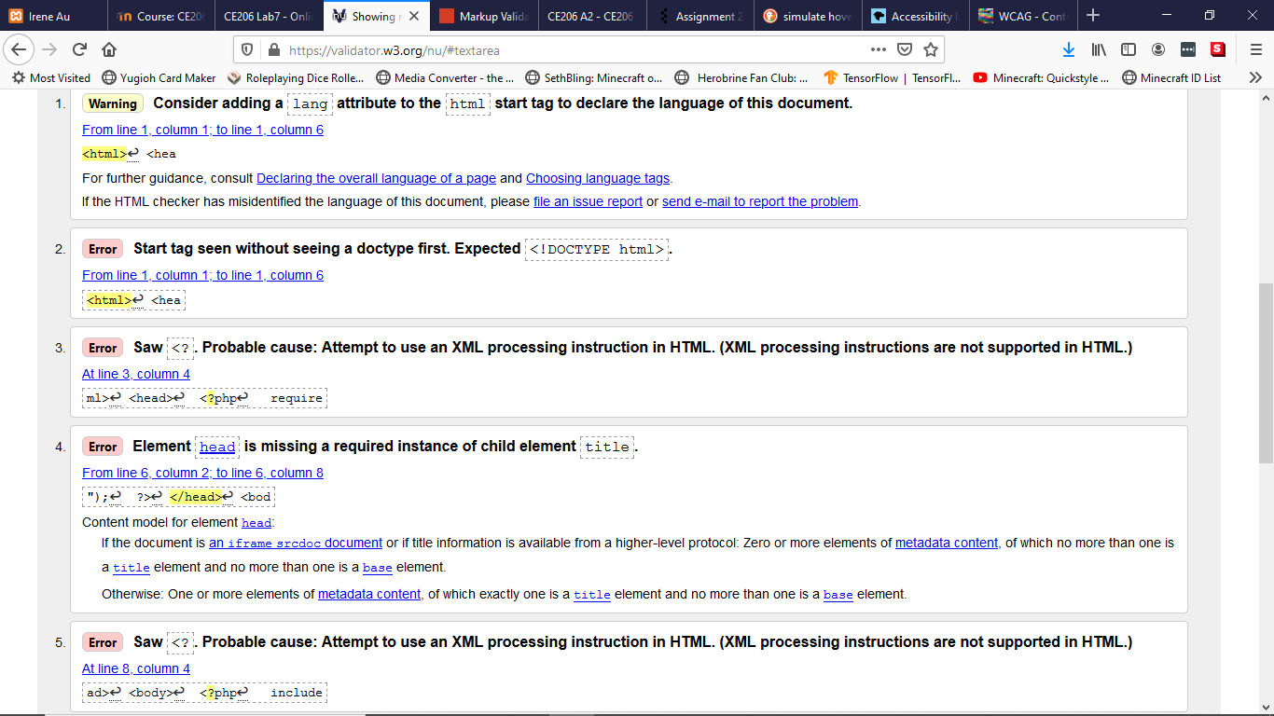

<title> is contained within the file “include/meta.html”:

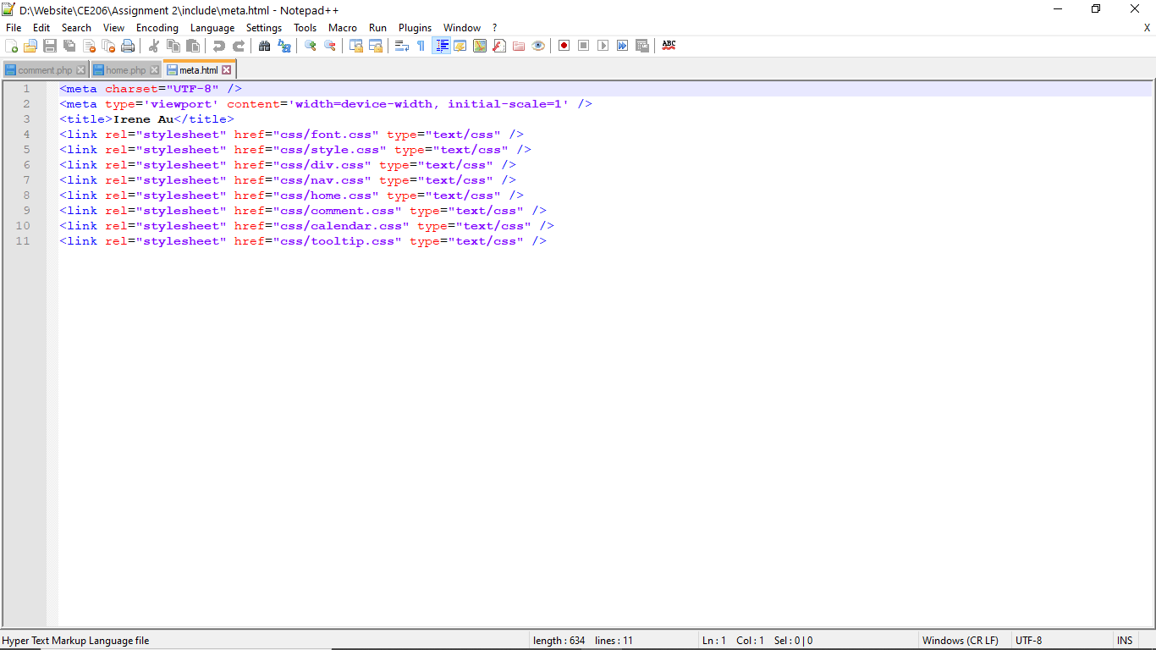

Also, since I make heavy use of PHP in my code to facilitate interactivity in my website, many instances of false positives occur due to this, like so:

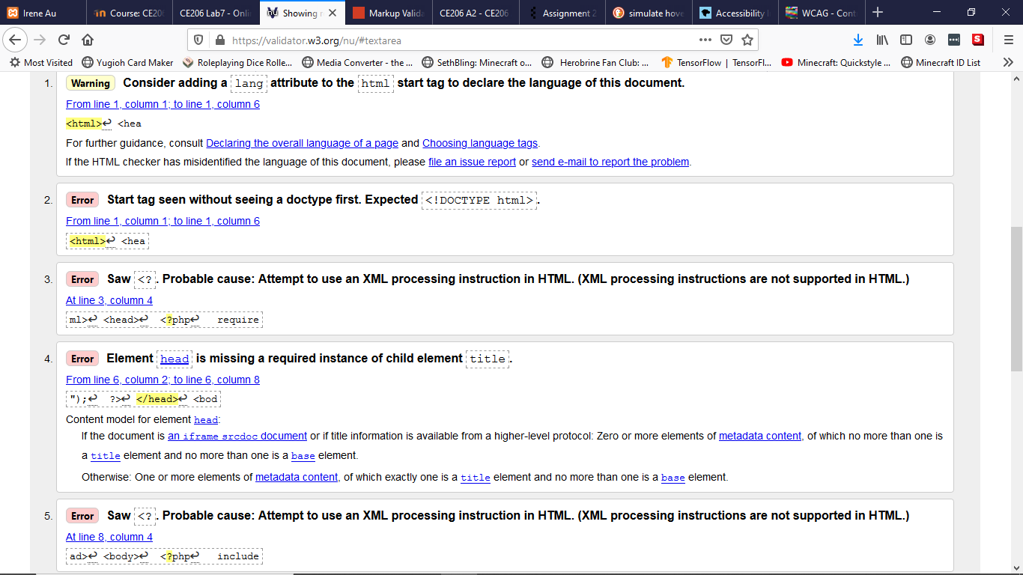



In addition, there are certain inner pages, such as calendar.php, that consist almost entirely of PHP code that echoes HTML. This means that the validator would incorrect assumptions about the type of script being read. This can be ignored.

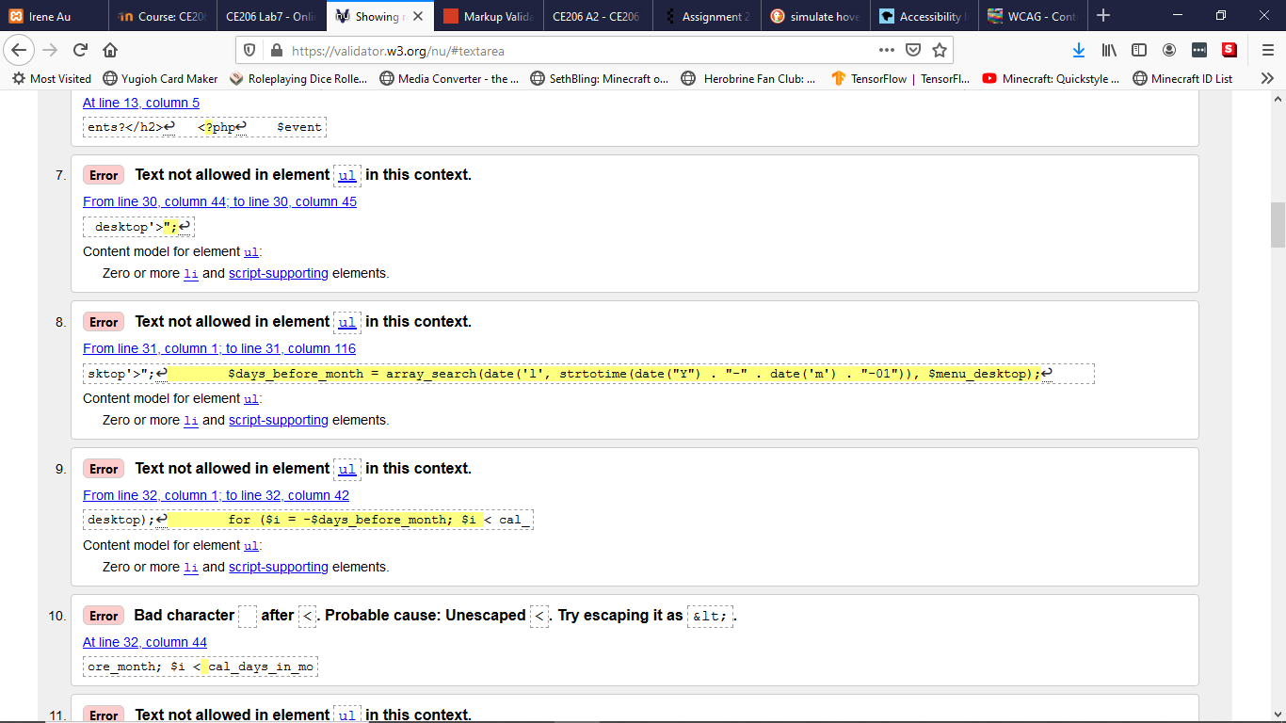

These issues make the site difficult to test using a HTML validator, however the CSS is regular, and so a CSS validator would work much better in this circumstance.

|  |  |  |
| --- | --- | --- |
| CSS File | Validator | Pass/Fail |
| Font |  | Pass |
| Style |  | Pass |
| Div |  | Pass |
| Nav |  | Pass |
| Home |  | Pass |
| Comment |  | Fail (I remedied this by adding px units to the end of these numbers.) |
| Calendar |  | Pass |
| Tooltip |  | Pass |

Areas Needing Improvement

As of now, there are a couple of big issues with the website. The first and most grevious is the calendar’s tooltip display. Currently, it does not resize itself to fit with the text in contains, and so a lot of text is cut out. This is very unhelpful and a massive UX failure, as the tooltips contain important information on description of events that a user would want to know.

In addition, there is a bug in the system where, if you have no reply selected, you will still be defaulted to reply to the most recently created comment. This is a big oversight that needs to be corrected.

There is also a small graphical error in the formatting of the comment boxes. The user and comment details at the top of each box should be formatted in one line, rather than formatted in a block style as they are currently.

Those are the three main problems I can see currently. Some are more major than others, however they all need to be fixed if the site is to improve.

Self-Assessment

After completing this assignment, I redid the skill tree that I ran through for the first assignment. It seems I have improved, particularly in areas of user discovery and understanding how to structure and manage the planning of a system.

